Friends of Tournament

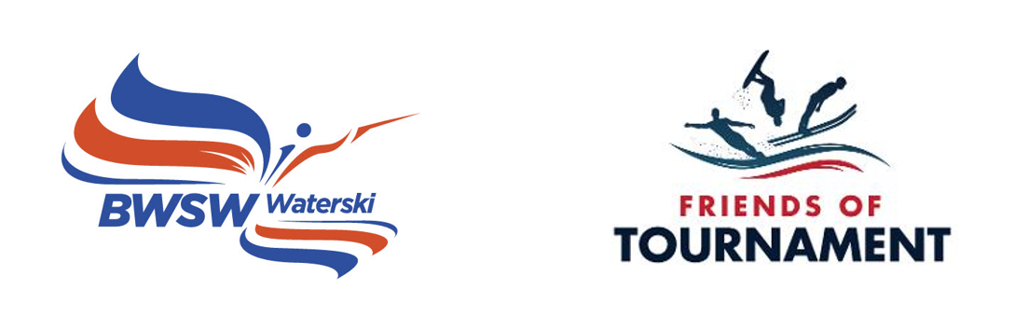
Monthly Newsletter

Issue No. 5 - August 2022

Friends of Tournament July 2022
- Gross amount raised to date - £237,803
- Prize Money – £64,189
- After Prizes – £173,615
- Spend to Date - £99,466
- Skier Travel Grants - £60,256
- Development Days – £15,024
- Trick/Jump Skis - £6,372
- Squad Training - £14,608
- Voucher Prizes - £1,205
- Paintings and Prints 2021 - £2,000
- Available Funds - £74,149
- FoT Bank Account @ 02/08/22 - £84,909
- Spend 2021 (Final) - £36,015
- Carry over into 2022 - £57,100
- Budget 2022 - £53,606
- Projected carry over into 2023 - £62,606
- Projected Budget 2023 - £57,770
- Projected carry over into 2024 - £44,066
- Changes this month: + 5 - 0
- 177 balls in the bag this month with prizes of £1,438.13
1st - £575.25
2nd - £431.44
3rd - £287.63
4th - £143.81
- So far 230 prizes have gone to 101 different winners.

The 200 Club Draw
The 67th 200 Club June 2022 prize draw has taken place during the National Championships at Oxford and the lucky winners are:
1st Phil Mitchell No. 52
2nd Phil Kinman No. 162
3rd James Timothy No. 67
4th Lesley Shanahan No. 132
Congratulations to them and a big thank you to everyone who supports FoT through the 200 Club.

SQUAD TRAINING
We have completed 3 Squad Training days for our Youth Skiers. Two days at Gosfield focusing on Slalom and Tricks and including a presentation from a nutritionist. Then a Jump day at PWTC again with a presentation, this time on Sports Psychology. Thanks to Vince and Charlotte for hosting these days.
DEVELOPMENT DAYS
We have so far run 6 Development Days at Lound, Rickmansworth, Llangorse, White Rose, Three Sisters with a total of 48 participants. Upcoming we have Cotswolds and Scotland. Thanks to the Coaches and in particular Glenn Campbell who has handled the last three events.

The 200 Club
We reached another milestone in the July 200 Club Draw with a record 177 balls in the bag. We had five new participants including White Cross Waterski Club, Mike McDonnell and Philipp and Amanda Scherer from Germany. Also, two winners from last month used their win to buy another ticket in the draw.
At Oxford this weekend we enjoyed the FoT Hospitality Popup made possible by a generous sponsor AND we had enough new signups to the 200 Club to finally achieve 200 ticket holders. This is a truly amazing achievement. Now we have to keep it at 200 and as we have some expiring tickets will still need to find some new 200 Club members. So, if you would like to go on the waiting list for the next available numbers a signup form can be downloaded here:


http://www.tournamentwaterskiing.org.uk/wp-content/uploads/2021/11/200-Club-Sign-Up-Form-2022.docx
Friends of Tournament End of Season Fund Raising Ball
November 19th – Hilton Northampton
We will be returning once again to the Hilton, Northampton for this year’s event so please save the date. Start to organize your table. More details will be published very soon.
British National Championships
The Combined Nationals took place at the Oxford Wake and Ski Club from 11th – 14th August. FoT was there and provided Coaching Voucher prizes to the Slalom, Tricks and Jump medalists in all the U17 and below divisions.We had 104 individual entries with 24 Open Skiers, 36 Youth Skiers and 41, 35+ Skiers as well as 3 Adaptive Skiers. FoT had a drinks tent and 200 Club members and other friends had a drink or two on us each day. The beer/wine tent has been kindly sponsored.
FoT Loan Kit
FoT has a range of skis and other gear, largely donated by generous supporters, that is available for loaning out. So if you are thinking about starting to trick ski but are not ready to buy a ski FoT can loan you a ski. If ultimately you want to carry on we will help you source a ski to keep. If you want to borrow kit please get in touch with Mark Beard at mark@ofbell.co.uk.
FoT Support Grant for European and World Championships
Due to only a small number of GB Skiers attending this years Open European Championships we have been able to increase the support grant for Skiers representing GB at the Open, Youth and U21 Championships from £700 to £900. This grant is to help with entry fees, travrl and familiarisation costs. Also for the World U17 Championship in Chile next January the grant is increased from £1,100 to £1,300.
Thank you for reading and for supporting Friends of Tournament.
Mark, Gavin and Dusko – FoT Committee

