Friends of Tournament

£437,740

Raised TO DATE

Friends of Tournament August 2025
- Gross amount raised to date – £437,739
- Prize Money – £120,730
- After Prizes – £317,008
- Spend to Date - £297,949
- Skier & Team Grants - £169,905
- Development Days – £40,884
- Training Camps - £19,195
- Backyard Events - £2,189
- Trick/Jump Skis/Medals - £11,821
- Squad Training - £24,878
- Coaching Vouchers & JC Award - £10,001
- Paintings and Prints - £2,425
- Promotional Merchandise - £16,654
- Available Funds – £19,059
- FoT Bank Account £15,420 @ 11/09/2025
- FoT Funds in Insignis Funds - £17,722
- Jill Howard Legacy Fund Bank - £1,783
- JHLF Investments - £204,582
- Final Spend 2024 - £50,275
Carry over to 2025 - £35,521
Projected Spend 2025 - £51,644

- 169 balls in the bag this month with prizes of £1373.13.
  - 1st - £457.71
  - 2nd - £366.17
  - 3rd - £274.63
  - 4th - £183.08
  - 5th - £91.54
- So far 409 prizes have gone to 141 different winners.

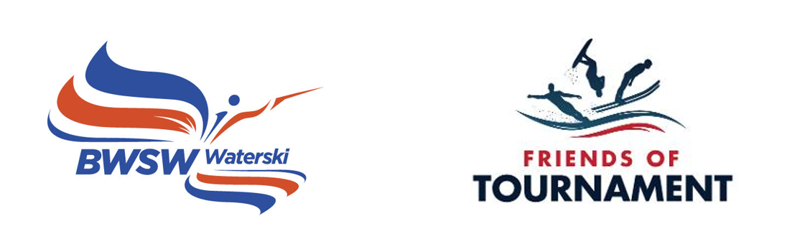
Monthly Newsletter

Issue No. 42 - september 2025

The 104th 200 Club Draw
The 104th 200 Club, August 2025 prize draw has taken place at HazelwoodsSki World during their recent Malibu Multi Ranking List competition With 169 numbers this month and a prize pot of £1,373.13 the lucky winners are:
1st Helen Newby-Ricci No. 39 - £457.71
2nd Alison Taylor No. 161 - £366.17
3rd Sale Waterski Club No. 103 - £274.63
4th Stuart Hills No. 117 - £183.08
5th Louise & Chris Roberts No. 49 - £91.54

Congratulations to them and a big thank you to everyone who supports FoT through the 200 Club.
We are now into our 9th year of FoT and have raised a gross amount of over £437,000, a fantastic achievement thanks to the generosity of all the FoT supporters.A video of the draw can be seen via the following link:
www.facebook.com/100063587380602/videos/1921367475109461 We want to keep membership of the 200 Club at 200 if possible but we have dropped down a few since the start of 2024. So, if you, your friends, or your club would like to join the 200 Club for the next available numbers a signup form can be downloaded here:
http://www.tournamentwaterskiing.org.uk/wp-content/uploads/2022/12/200-Club-Sign-Up-Form-2023.docx
It would be great to sign up more clubs. Your club funds may benefit while supporting the sport.
The Jill Howard FoT National Youth Festival 2026
We are looking for a club to host the 2026 Youth Festival. If you are interested, please contact Dush at dushylukic@hotmail.com. Hosts so far have been Oxford, Hazelwoods and Lound.

Loan Kit Scheme
The Loan Kit Scheme is now being managed by Cora Coster and Adele Fearn. The arrangements are that a piece of equipment can be borrowed for six months but then must either be returned or purchased. If you have equipment on loan that should be returned please contact Adele or Cora. An extension to the loan period can also be requested. If anyone is looking for kit please contact Adele or Cora to see what is available. Cora Coster at cora@carpolinsurance.co.uk or Adele Fearn at adelefearn99@gmail.com
Donations of kit and equipment would be gratefully accepted
Projected Spend 2025
FoT Basic
The projected spend for 2025 is now £51,644. With this spend we are now forecasting a carryover amount into 2026 of around £18k. This is reduced from earlier estimates primarily due to fewer Development Days and training camps than originally planned. It does mean however than we can sustain a similar spend in 2026.
Participation Grants for World and E&A Championships |  | £31,500
Development Days |  | £2,730
Training Camps |  | £2,500
Squad Training Vouchers |  | £5,000
Nationals Medals |  | £1,300
Coaching Vouchers 2024/25 |  | £3,500
Equipment/Merchandise Purchases |  | £5,114
Grand Total Spend |  | £51,644

Jill Howard Legacy Fund
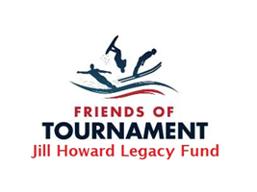
Although flexible the general plan is to spend around £17k each year on projects that Jill would have appreciated. This would mean the fund lasting for about 15 years. So for 2025 the plan so far is as follows:

Five Squad Grants |  | £5,000
Three D Day Skier Grants |  | £1,500
Backyard Event Support |  | £3,600
Jill Howard Youth Festival |  | £1,000
Technical Support Grants |  | £4,500
Officials Support/Training |  | £1,400
 |  | £17,000

Looking Forward to 2026

We are almost at the end of the season and are starting to think about 2026. We are looking for a couple of volunteers to help us organise and run Development Days next year.
So if you would like to help us out please contact Dush at dushylukic@hotmail.com.

Gavin, Dush and Stuart
FoT Committee

Supported By:


